**PROJECT REPORT ON MAY**

This form is a required review of our project on start-ups which we are researching on.

13 May 2015:

* The topic for this day was team leadership methodology.
* We started by explaining leadership:
* It is to provide direction, instructions and guidance to a group of individuals who can also be known as a team for the purpose of achieving a certain goal.
* We mentioned the roles
* Leadership styles a leader has to take note of and abide by them.

14 May 2015

**Organizational culture:**

Is a system of shared assumptions, values, and beliefs, which governs how people behave in organizations? These shared values have a strong influence on the people in the organization and dictate how they dress, act, and perform their jobs. Every organization develops and maintains a unique culture, which provides guidelines and boundaries for the members of the organization.

**Characteristics of Organizational Culture**

The seven characteristics of organizational culture are:

* 1.Innovation

– We have the company culture that places a high value on innovation employees are encouraged to take risks and innovate in the performance of their jobs.

* 2.Attention to Detail

That where employees are expected to be accurate in their work to an organisational culture.

* 3.Emphasis on Outcome

-When a company focuses on results, but not on how the results are achieved.

* 4. Fairness Orientation

Company that sees the importance of treating their employees with respect and dignity.

* 5.Teamwork

Companies that organize work activities around teams instead of individuals.

People who work as a team tend to have a positive relationship with their co-workers and managers.

* 6 .Competitive Orientation

This characteristic of organizational culture dictates whether group members are expected to be assertive or easy-going when dealing with companies they compete with in the marketplace.

Companies with an aggressive culture place a high value on competitiveness and the competition at all costs.

15 May 2015

**ENTRPRENEURSHIP**

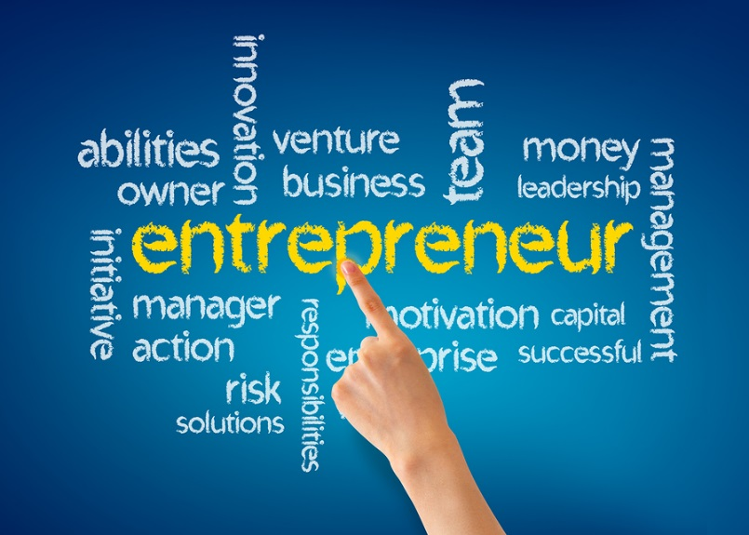

Entrepreneurship is the process of starting a business or an organization.

Entrepreneur is an individual who, rather than working as an employee, runs a small business and assumes all the risk and reward of a given business venture, idea, or good or service offered for sale.

**HOW TO IDENNTIFY SKILLS**

Everyone has skills from life experiences that we can start to build a business out of and there is practically an infinite amount of people online that could be in the market to appreciate the skills and expertise and be willing to pay something for them.

**AS AN ENTREPRENEUR YOU HAVE TO TAKE RISK**

If you hope to come out on top, you need to not only face risks head on but actively embrace them.

To succeed, you have to take the leap and choose to flutter.

**AS AN ENTREPRENEUR YOU HAVE TO SACRIFICE**

To be a successful entrepreneur you have to step out of your comfort zone and approach uncomfortable situations with confidence.

Learn to thrive in uncomfortable environments.

By leaving the comfort zone you are making a huge investment for your life.

|  |  |
| --- | --- |
| **TEAM NAME** | **TEAM INCEDE** |
| **PROJECT NAME** | **START-UPS** |
| **PROJECT TOPIC** | **TEAM LEADERSHIP METHODOLOGY, CULTURE,AND ENTREPRENEURSHIP** |
| **PROJECT DIRECTOR** | **MALUSI GCAKASI** |
| **COMPLETION DATE** | **31 MAY 2015** |

**CURR**

**REPORT ON PROGRESS.**

**REPORTS BY DATE**

|  |  |
| --- | --- |
| **DATE** | **09 MAY 2015** |
| **REPORT** | **TEAM LEADERSHIP METHODOLOGY, CULTURE AND ENTREPRENEURSHIP** |
| **GROUP MEMBERS** | * **SISANDA GUNTSU** * **ONELA MPAMA** * **AKHONA GOTYE** |

## What is lean methodology?

* It is an approach to business development that is based on the principles of lean production, a manufacturing methodology that values a business ability to change.
* This methodology consists of structure and focuses on three phases which are:
* built
* Measure
* Learn

Lean techniques

It has 5 techniques for the process of guiding implementation

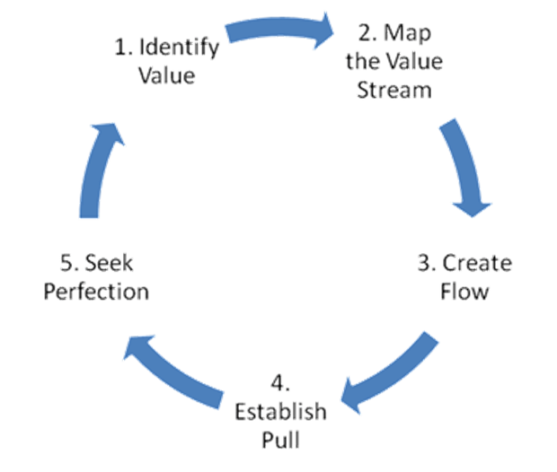

Market infrastructure

* The buying
* process includes everything from the customers being aware of the product to evaluation of it,

Purchase and finally the usage

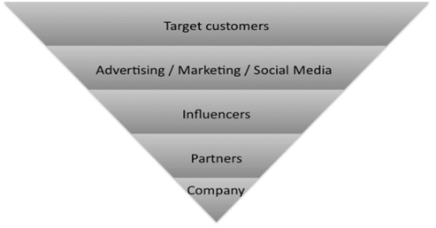

TEAM LEADERSHIP



**WHAT IS LEADERSHIP:**

It is to provide direction, instructions and guidance to a group of individuals who can also be known as a team for the purpose of achieving a certain goal.

The knowledge, skills and abilities required for team leaders include subject matter expertise, problem-solving, team-building and innovation.

**There are various roles to be followed in leadership**:

* You have to develop useful strategy for the team to reach its goal.
* Provide training for the team members.
* Communicate clear instructions to the members.
* Listen to team members.
* Listen to team member’s feedback.
* Monitor and manage the flow of day to day operations.
* Distribute reports to the appropriate personnel

LEADERSHIP STYLES:

Leadership consist of different styles which are:

COMMANDING

Telling the team what to do in urgency and when there is no time.

AFFILIATIVE

Focusses on emotional needs than work needs.

AUTHORITIVE

Mobilising peers towards a vision. DEMOCRATIC

Uses participation and listening to both the bad and good news and make the team members the decision makers.

PACE SETTING

Builds challenging and exciting goals for members.

COACHING

Connecting corporate goals whilst helping people find their strengths and weaknesses.

**START-UP TEAM FORMATION** 

* Is the use of different interventions aimed at enhancing social relations and clarifying member’s roles in solving problems.
* To achieve results, meeting goals and accomplish tasks but mostly to improve functioning and effectiveness.

**Building a team in startups you need to follow some steps which are:**

* Identify positions.
* Prioritize: who do you want to hire.
* Hire vs Partner
* Full time vs Contract: hiring a full time member is a big risk whereas its easy to get rid of a contract member.
* Identify candidates: start networking in events.
* Interviews: consider members from a lager pool of potential candidates.

STAGES OF TEAM FORMATION

* There are certain stages through which the team must progress to become highly effective namely:

**FORMING**

Finding out about each other and establish ground rules.

**STORMING**

Where by members engage in conflicts and test limits.

**STAGES OF TEAM FORMATION**

* **There are certain stages through which the team must progress to become highly effective namely:**

**FORMING**

* **Finding out about each other and establish ground rules.**

**STORMING**

* **Where by members engage in conflicts and test limits.**
* **NORMING**

Team norms and customs are established to focus on team goals.

* **PERFOMING**

Getting the task done and achieving the overall objective.

* **ADJOURNING**

When the team disband because the mission has been accomplished.

START-UP TEAM FORMATION

* Is the use of different interventions aimed at enhancing social relations and clarifying member’s roles in solving problems.
* To achieve results, meeting goals and accomplish tasks but mostly to improve functioning and effectiveness.

MENTAL CHALLENGES OF BUILDING A TEAM



1. The core people
2. Get the best of people
3. Hire an HR person
4. Look for common sence
5. Look to the experience of others

* It says any successful teamstarts with 3 core people,that is me,myself &I.
* Without those three you are going nowhere.
* They the very core of your business.

BLUETOOTH RING.

The Nod ring is a Bluetooth-enabled gesture controller that connects to your smartphone to accomplish a number of input and controller tasks all by using natural motions with your finger.

This ring can be used in extending the capabilities of your smartphone, the ring can also be connected to other smart devices, such as a smart television and other Internet-connected devices like the Nest.

* If a device doesn't have Bluetooth capability, you can connect the ring to your smartphone, which will then connect to the device via Wi-Fi.
* The ring can be used to type text and surf the web on a tablet.
* To answer a smartphone call and even play a game on a tablet.
* Other programmable functions include using it as a trigger to take selfies with your smartphone, or as a controller for your smart television.
* It is stored in a waterproof, black plastic casing.
* The ring's battery is designed to last about one day and can be easily be recharged via its holding case.
* It has the flat surface which is meant to be worn pointing inwards your palm,
* Has tiny small buttons that can be programmed for a number of functions like volume up and down capacitive touch pane.
* Its functions are controllable through associated apps such as iOS and android.
* The Nod is designed to allow you to use more natural gestures with your finger.



BACKGROUND

Technological innovation and entrepreneurship are considered to be key factors to national economic growth

Inability to exploit technological opportunities that occur and lack of innovative efforts can cause slow growth in countries.

Unfortunately, a majority of new enterprises fail within the first years of existence. Statistics show that about a third of the Swedish firms started in 2005 had failed three years later and similar numbers can also be found for U.S. start-up.

A common advice to entrepreneurs is to write a solid business plan before they launch their new ventures. Writing business plans has traditionally even been considered to be the most important feature of entrepreneurship courses by entrepreneurship educators.

Even though business plans have become deeply rooted as a key component for new ventures, the importance of business planning for start-ups has been discussed and questioned during the last years.

The debate about business planning for new firms can be categorized into two broad groups. The proponents of business planning argue that a systematic, prediction-oriented and formal planning approach results in superior venture performance The other group of researchers argues that entrepreneurs instead should be focused on flexibility,

learning and controlling resources (Brinckmann, Grichnik & Kapsa, 2010). Critics primarily consider formal business plans to be an important requirement when entrepreneurs seek formal venture capital for the new ventures (Lange et al., 2007; Zacharakis & Meyer, 2000; Gruber, 2007) meanwhile the business plan itself is not perceived to be a key determinant for success (Lange et al, 2007; Bhide, 1999). Too rigorous planning in early phases has even been considered to be “at worst, fundamentally misleading” (Alvarez & Barney, 2007, pp. 12) and “will almost always lead to failure” (Furr & Ahlstrom, 2011, pp. 10).

**Entrepreneurial decision-making**

Increasing attention in recent years has been given to understand what entrepreneurs do and what characterizes successful entrepreneurs and the methods that they use. One central aspect within the field of entrepreneurial research is how opportunities are considered.

The entrepreneurial discovery process is represented in drawing upon the approach about the growth of knowledge in order to describe entrepreneurship and market processes. Harper’s development of the Popperian approach was initiated as an alternative to Kirzner’s theory of entrepreneurship, which is based solemnly on a set of highly constructive assumptions.

**Lean Start-up methodology framework**

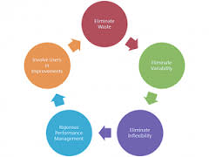

The framework is used to complete the case study and InCorp is presented. The framework is based on the four authors; Eric Ries, Steve Blank, Nathan Furr and Paul Ahlstrom. We studied the field online in for example blogs and forums and found that these authors best represent LSM, especially Ries and Blank.

Blank was the pioneer in the field and the one who introduced the concept customer development describing the process for how entrepreneurs should test and refine business hypotheses through customer conversations. His book, “The Four Steps to the Epiphany” from 2006, in which he describes the process of customer development has become a must read for Silicon Valley entrepreneurs and is highly mentioned in the community. Ries is a former student of Blank and has popularized the concept Lean Startup in his blog and subsequent book “The Lean Startup” from 2008. He has received a lot of attention with this book and it was therefore natural to include him in the framework.

Further, Furr and Ahlstrom has gained a lot of attention in the field recently for their book “Nail It Then Scale It” from 2011. They provide prescriptive and hands-on tips to the entrepreneur. We believe they are a good complement to Blank and Ries, and they are also respected in the LSM community. In the study of the field three other authors that needs to be mentioned was found. Brant Cooper and Patrick Vlaskovits have received a lot of attention for their book “The Entrepreneur’s Guide to Customer Development”. However, it is based on the work of Ries and Blank so we believe it is better to include the sources. The last author is named Ash Maurya who has written the book “Running Lean”. He is not perceived to bring anything new to LSM and is therefore not included in the framework.

**Research approach and design**

The purpose of this thesis is to identify challenges when implementing LSM for early-phase manufacturing firms with physical products.

Due to the nature and purpose of this research, a single case study was an appropriate research design since case studies allow the investigator to retain the holistic and meaningful characteristics of real-life events in this case for the LSM process.

According to Yin the classification of research questions being asked is the first and most important condition for differentiating among various research methods. “What” questions can be broadly categorized into exploratory- or prevalence nature. The two research questions in this study are of exploratory nature where the goal is to develop an initial analysis and pertinent hypothesis of problems using LSM outside the IT-industry. An exploratory type of research question is a justifiable rationale for conducting a case study (Yin, 2009). Further, case studies are particularly suitable for research questions that are of a how/why-character Bryman & Bell and do not require control of behavioural events and focuses on contemporary events.

A case study is therefore an appropriate research design where large amounts of data were collected to provide a deep understanding of challenges associated with LSM.

As in a case study, the focus in this report is on elucidating the specific details of the process at InCorp. InCorp was perceived to be suitable research object because of its characteristics of an early-phase manufacturer of physical products that currently is searching for a scalable business model. Further, the company’s technology could potentially be used in multiple different applications potentially making InCorp suitable for the LSM process which is used to test and refine business model hypotheses.

Conclusions generated from the single case study at InCorp were used to evaluate the theories regarding the LSM.

Even though the case study is an appropriate research design to capture in-depth contextual dynamics, many researchers nevertheless disdain the design.

One of the main concerns about the strategy have been the lack of rigor case study research where systematic procedures have not been followed or biased views have influenced the findings and conclusions.

A systematic procedure has therefore been pursued to assure that data and evidences are reported consistently throughout the study.

Another common concern for case studies is the rather limited basis for scientific generalization.

Case studies could result in too complex theories stemming from large amount of data and theories that are too narrow, thus not generalizable.

The goal of the thesis is, however, to expand and asses LSM and its associated problems and not to provide a statistical generalization of the frequencies of problems.

There is a belief that the findings from the case study can be applicable to companies with similar characteristics as InCorp, due to the deep contextual understanding retrieved, and thereby provide a valuable initial effort to assess LSM.

The case study provides a holistic and in-depth view of why some aspects of the LSM might be difficult to implement. However, the generalizability problem should indeed be accentuated.

The research strategy pursued in this research can be categorized as action research, a term popularized by Professor Kurt Lewin.

A distinct feature of action research is an active and interactive self-involvement of the researcher in a problem solving context McKay & Marshall.

Action researchers are thus not only observing something happing, instead researchers take an active role in making something happen.

Action research was an appropriate approach in this particular case since it allowed people to systematically test LSM in a real-life situation.

A certain ability was there to control and ensure that the principles of LSM were properly followed throughout the process.

This is a vital aspect in order to make an accurate assessment of the LSM and associated challenges.

**Action Research Goals**

The goal of action research is two-folded.

* Solve a problem.
* Contribute to science.

The process should thus be beneficial for both researcher and organization according to Baskerville & Wood-Harper.

They took therefore an active part in and drove the LSM process for InCorp and at the same time stood back from the action and analyzed the process in order to be able to contribute to the body of knowledge of entrepreneurial decision-making.

This gave us a holistic understanding of the process and the opportunity to recognize its complexity.

The process followed during the case study can be represented by two cycles.

**Problem solving interest.**

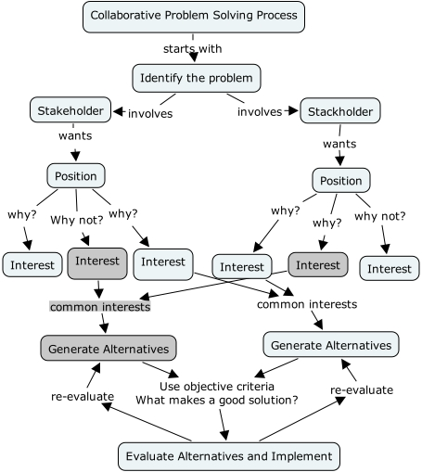

This was then followed by fact finding about the problem where finding out more about the context of the problem and stakeholders in the process.

A problem solving strategy was then planned which then proceeded with the implementation of a number of action steps (principles of LSM) that were monitored and evaluated in terms of the effect on the initial problem.

Depending on whether considering the outcome to be satisfactory and that the problem was solved, a decision was made whether to exit from the situation or to continue and make additional changes to the problem context.

The issue of involvement in the process and potential impartiality are something that needs to be reflected upon.

The people who entered the process were given names as participants and researchers due to the dual interest in the process.

It is thus necessary to reflect about the dual role which potentially could have biased the data gathering and analysis.

It is possible that the fact was not the actual management of the case company could have affected the results such as lower barriers to get access to customers and opportunity to fully get dedicated to the project.

The management for the case company InCorp had other commitments that they had to honor.

**THE TESTED LSM PROCESS**

Generic phase of LSM process Characteristics Phase 1: Create and validate the problem hypothesis.

* The purpose of phase one was to create and then validate the problem hypothesis by interacting with potential customers.

Identify suitable segments.

* The creation of the hypotheses was an iterative process, where the collected information could be put together into a preliminary hypothesis.

Another challenge during the identification of customers to contact was the absence of a large potential customer base to target.

The hypothesis was then discussed with InCorp’s management to get more input from their experience in the segments, but also whether InCorp’s solution was suitable for these problems.

Formulate hypotheses about product, customer problems and big idea hypothesis.

Find potential customers Get out of the building and test hypotheses through customer conversations.

steps: 1. Contact and schedule interviews.

Test and modify hypothesis

**Exploration of market attractiveness**

The size of the market was estimated by investigating the revenues of the competitors and through looking at the potential customers’ investment needs.

Through discussions with InCorp and the potential customers together with searches on Google the competitors to InCorp were mapped.

The revenues of competitors were found at business directories while the investment needs for potential customers were found in interviews.

The paper & pulp segment was big enough for InCorp to pursue solely, while industrial frying would constitute of a substantial part of InCorp’s forecasted growth, but was not large enough for to focus on solely.

A decision to pursue the industrial frying segment of limited size was taken after discussions with the management at InCorp.

The segment was seen as large enough to be of value to InCorp.

The competition was rather limited in all of the segments and was not seen as a problem.

As the technology is patented and the technology is a relative advantage InCorp has a competitive advantage in it.

Due to mainly time limitations only the industrial scorching segment was pursued.

Except the lack of time, the paper & pulp segment was unfluctuating more focused on reliability and the po tential customers emphasized that they would only like to buy from established suppliers.

The recommendation to InCorp was therefore to pursue the segment by approaching the established suppliers.

The industrial frying segment was pursued to the next phase

REFERENCES:

* Startup Methodology
* Wikipedia
* <http://theleanstartup.com/principles>
* steveblank.com/2011/12/13/the-**startup**-**team**/
* www.forbes.com/sites/groupthink/